e-PU Cabinet V2
Project plan

VDL order number
Customer | Internal
End User | External
Item | Battery Energy Storage System
Project Lead | L. Rietkerk

Introduction 1
Abbreviations and Definitions 2
Research background 2
Objectives 3
Deliverables 4
Project Scope 4
General Scope of supply 5
Deliveries 5
Activities 5
Progress review 6
Project assessment and risk management 7
Cost, Budgets & Engineering team 7
Engineering Team 8
Requirements / Prerequisites 8
Scope of work company departments and communication 8
Scope of engineering 9
Scope of Quality 9
Scope of operations 9
Scope of procurement 9
Scope of packaging 9
Communication 9
Project document list 10
Project Planning Github 10
Tollgate review and accreditation 11

Introduction
The e-Pu Cabinet V2 project focuses on the development of a low-cost, high performance stationary Battery Energy Storage System (BESS) platform using standard commercial hardware combined with VDL Energy systems control software.
The project aims to develop a versatile energy storage solution capable of grid following and grid forming operation. The system shall support multi BESS up to 1 MW, peak shaving, microgrid, PV controls, generator controls (fixed power) and black start.
The development is driven by client demand for stationary energy storage solutions that combine low hardware costs with software functionality and high system reliability in order to improve competitiveness in the market.

Abbreviations and Definitions
Abbreviation | Definition
BESS | Battery Energy Storage System
EMS | Energy Management System
HMI | Human Machine Interface
P/Q | Active/Reactive power
SCR | Short Circuit Ratio
THD | Total Harmonic Distortion
TRL | Technology Readiness Level
EMC | Electromagnetic Compatibility
PLM | Product Lifecycle Management

Research background
The stationary energy storage market is rapidly evolving toward higher performance systems, including capabilities for microgrid operation, fast response control and integrated management of PV and generator assets.
Many commercially available off the shelf BESS cabinets provide basic energy storage functionality but offer limited support for advanced applications such as microgrid operation, fast grid forming control, coordinated operation of multiple BESS units and integrated management of PV and generator assets.
To address these limitations, VDL energy systems intends to develop its own controls including both hardware and software components, while using cabinet hardware. This approach enables the realization of advanced control functionality while maintaining a cost-effective system architecture.
The e-Pu Cabinet V2 project addresses these limitations through:
- VDL developed controller software
- Fast grid forming and grid following control loops
- Multi BESS load sharing and redundancy
- PV system controls
- Generator controls
- Improve reliability with fallbacks
The project includes plans for a second phase. However, this phase falls outside the scope of the current project plan and will not be discussed further.

Objectives
Main objectives are:
- Development of low-cost e-Pu cabinet using Solar East hardware components
- Integration of VDL control hardware
- Development of VDL energy systems main controller software.
- Realization of stable grid forming and grid following operation
- Development of multi BESS microgrid functionality up to 1 MW
- Development of black start and automatic recovery functionality
- PV control and curtailment functionality
- Development of redundancy and fail safe operation
- Realization of a unified VDL service portal
- Compliance with: PGS37-1/Dutch grid code/CE regulations
System Requirements
Parameter | Target
Rated Power | 125 kW
Peak Power | 110% continues, 120% for 1 minute
Usable Capacity at SOH 99% | 250 kWh
Parallel systems | Up to 1 MW
Grid response time | <100 ms
THD | <3%
Efficiency | >88%
Uptime | >98%
Environment temperature | -20 - 55
Communication | Modbus TCP/CAN/Ethernet
Safety compliance | CE / PGS 37-1
Grid frequency | 50/60 Hz
Noise | <75 dB
IP rating | IP54

Deliverables
- Functional e-Pu cabinet with VDL controls
- Grid forming and grid following functionality
- Multi BESS load sharing capability
- PV control
- Generator control functionality
- Service portal and HMI
- CE documentation
- PGS 37-1 compliance documentation
- Operation manual
- Maintenance manual
- Test reports and validation documentation

Project Scope

General Scope of supply
Following a technical and commercial evaluation of available BESS cabinet platforms, the Solar East cabinet was selected as the preferred hardware platform for the e-PU Cabinet V2 project. The platform provides a suitable foundation in terms of power rating, energy capacity and overall system requirements.
The project covers the development, integration and validation of a VDL controlled BESS based on the Solar East cabinet platform. While existing cabinet hardware is retained, the complete control architecture will be replaced and extended with VDL developed hardware and software solution. This enables the implementation of advanced energy management and microgrid functionalities while maintaining cost effectiveness.
The resulting system shall support both grid following and grid forming operation and provide the following functionality:
- Multi BESS operation up to 1 MW
- Peak shaving and load management
- PV and generator integration
- Black start and automatic recovery
- Microgrid operation with load sharing and redundancy
- Grid code compliant operation (NL/EU)
- Safe operation under fault and island condition
The system is intended for stationary Commercial and Industrial (C&I) applications and shall be designed to meet standards of reliability, safety and operational be suitable for industrial deployment with high reliability.

Deliverables
The project delivers a validated and documented energy storage control solution integrated into the Solar East cabinet:
- Fully integrated e-Pu cabinet with VDL control system
- Grid forming and grid following operational modes
- Multi BESS load sharing and microgrid control functionality
- PV curtailment and generator control interfaces
- Black start and automatic mains failure recovery functionality
- Redundant operation strategies and fail safe modes
- HMI / service portal for monitoring and diagnostics
- Control Software Package
- Validation and test reports
- CE technical file and compliance documentation
- PGS 37 -1 compliance documentation
- Operation and maintenance manuals

Activities
Project execution is structured in TRL based phases covering design, integration, validation and readiness.
- TRL 1 – Project Scope & Documentation
  - Define project scope
  - Create project documentation
  - Define requirements
- TRL 2 – Datasheet & Concept Design
  - Collect hardware specifications
  - Create concept design
  - Review standards and regulations
- TRL 3 – Controller Integration
  - Integrate VDL controller
  - Verify subsystem controls
  - Initial communication testing
- TRL 4 – Stable Grid Control
  - Stable F/U control
  - Stable P/Q control
  - Grid forming setup validation
- TRL 5 – Performance Validation
  - SCR testing
  - Load step validation
  - Synchronization testing
  - Multi BESS testing
  - Protection testing
  - Overcurrent and overvoltage validation
- TRL 6 – Field Readiness
  - Generator stability tests
  - PV controls test
  - Microgrid validation
  - CE documentation
- TRL 7 – Pilot validation
  - Reliability validation
  - Customer feedback processing
  - Uptime validation (98%)
- TRL 8/9
  - Commercial rollout
  - Product optimization
  - Market feedback implementation
Each TRL phase ends with a technical review and formal approval gate before continuation.

Progress review
Project progress is monitored through a combination of engineering and management reviews:
- Weekly project team meetings for technical alignment and planning
- Bi weekly engineering management progress reviews
- TRL milestones are defined based on a review and documented in the TRL tollgate folder. For each TRL stage, a Word template is completed and used to decide whether progression to the next level is approved.
- Continuous updating of the planning and keeping track of the tasks in Github
Standard progress reporting includes:
- Technical progress
- Open actions and risks
- Budget and resource usage overview
- Identification of roadblocks
All project-related information will initially be stored in the VDL OneDrive to ensure a centralized and accessible workspace for all team members. In a later phase, the data will be migrated to the G drive for long-term storage and organization.
As the project approaches completion, key deliverables will be transferred to the G drive, while files requiring version control and review—such as design documents and 3D models—will be managed in PDM.

Project assessment and risk management
Key technical and project risks include:
- Integration complexity between standard cabinet hardware and VDL control systems.
- Stability and robustness of grid forming control under dynamic loads
- Multi BESS synchronization and load sharing performance
- Compliance with CE and PGS37-1 requirements
- EMC and power quality constraints
- Dependency on supplier hardware quality and documentation
- Communication reliability between subsystems
- Thermal and protection systems performance under fault conditions
- Manufacturer documentation reliability and availability
- Quality of hardware
Risk mitigation is achieved through:
- Incremental TRL based validation
- Early integration and sub system testing
- Progressive compliance verification during development
- Defined fallback and redundancy strategies
- Structured test plans per function and subsystem

Cost, Budgets & Engineering team
Project cost are primarily driven by control integration hardware, software development, power electronics interfaces, safety systems and testing.
A key project constraint is to minimize controller material cost, with a target of:
- Additional material cost < 3500 euro per system

Engineering Team
Required disciplines
- Project Lead (Lennard)
- Software engineer (Tim / Robert)
- Electrical engineer (Szabi/ Robert)
- Safety / compliance engineer (Gertjan / Daria)
- Test and validation engineer (Tim / Lennard)

Requirements / Prerequisites
Before execution the following prerequisites must be in place:
- Approved project number and budget allocation
- Confirmed e-Pu cabinet V2 delivery schedule
- Established Github project and planning
- Defined PLM and document control structure (where to save files)
- Assigned engineering team and role allocation

Scope of work company departments and communication

Scope of engineering
Responsible for system design, controller development, integration, testing and technical documentation:
- Systems architecture and control design
- VDL software development and integration
- Test specification and execution
- Supplier technical coordination
- Documentation and technical reporting

Scope of Quality
Responsible for compliance and certification
- CE certification support and technical file preparation
- PGS37-1 compliance verification
- Safety assessment and documentation

Scope of operations
Responsible for execution and production readiness:
- Material planning and logistics
- Workshop preparation and support
- Assembly and integration
- Installation and handling procedures

Scope of procurement
Responsible for sourcing and supplier management
- Procurement of hardware components
- Supplier coordination and follow-up
- Lead time tracking
- Cost control

Scope of packaging
Responsible for physical system integration
- Cabinet assembly and electrical integration
- Pre-assembly of control and power components

Communication
Communication is structured to support fast engineering execution with minimal overhead:
- Daily informal alignment
- Weekly update with involved engineers
- Bi-weekly update management progress review
- Formal reviews after every TRL milestone
- Action tracking in Github planning

Project order numbers and Hours
Project Order number | TRL | Sub | Bewerkingsnaam | Amount of Hours predicted | Amount of Hours used
9013888 | 1 | 000 | 107 | 80
9013888 | 2 | 000 | 207 | 120
9013888 | 3
9013888 | 4
9013888 | 5
9013888 | 6
9013888 | 7
9013888 | 8
9013888 | 9

Project Planning Github
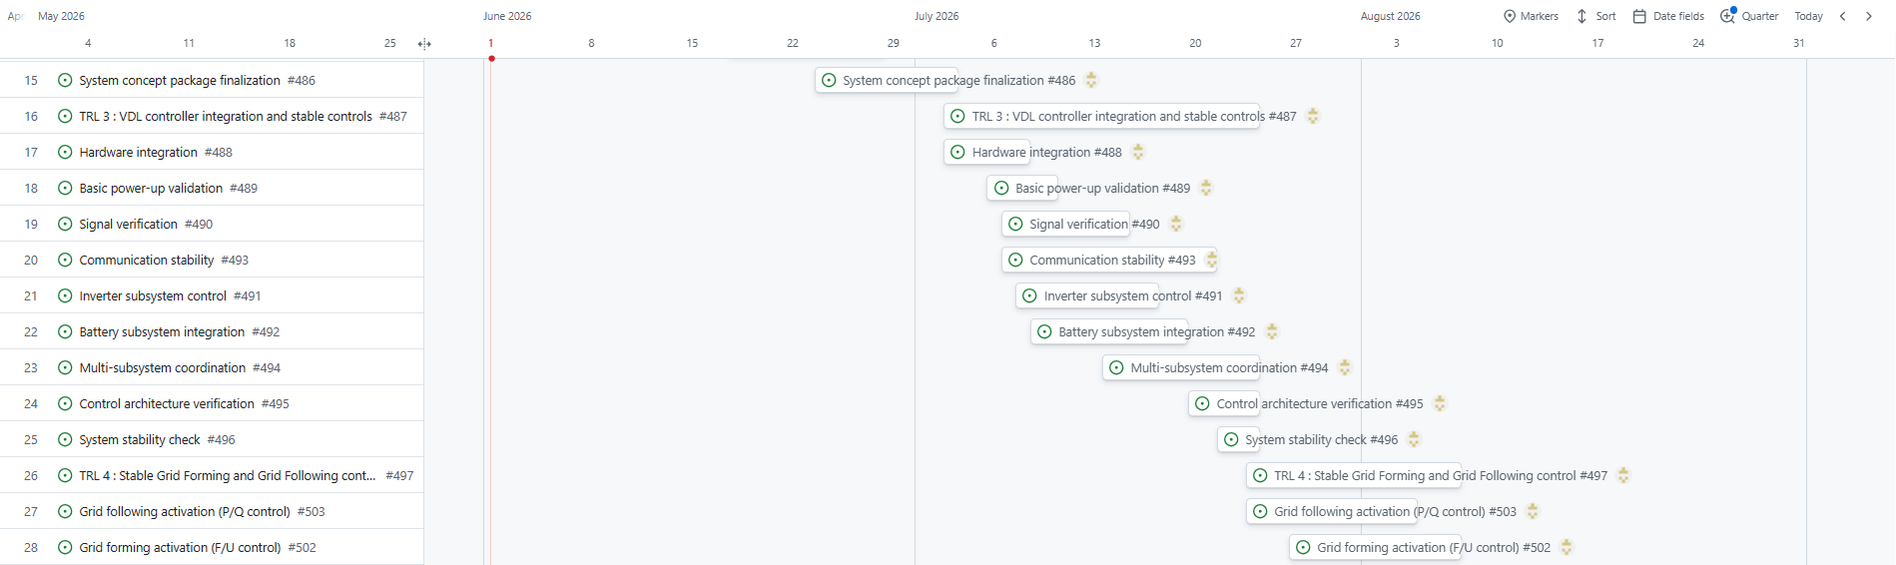
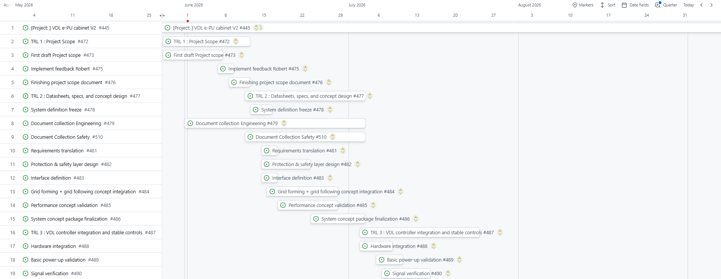

Tollgate review and accreditation
After completion of each TRL phase a formal tollgate review is performed to assess technical maturity, compliance with requirements and readiness to proceed to the next development stage. The review evaluates system performance, integration status, risks and alignment with the defined project scope and deliverables.
The tollgate Is based on objective evidence from test results, design documentation and subsystem validation. Each TRL gate requires confirmation that all mandatory deliverables for the respective phase have been completed or that any remaining open items are properly documented with mitigation actions and no blocking impact on progression.
Key assessment criteria:
- Completion of TRL specific deliverables as defined in the project plan
- Successful implementation and verification of key system function relevant for the TRL phase.
- Resolution of critical technical issues identified during the previous phase.
- Completion of required tests activities and documentation updates.
Each tollgate concludes with one of the following actions:
- Approved
  - TRL phase completed and project may proceed to next TRL
- Approved with actions
  - TRL completed with non-blocking open items tracked and documented.
- Not approved
  - TRL criteria are not met, additional work required before continuation.
Technical specification of the hardware from Solar East.
Systeem model | SolarEast
DC
Battery Cell Type | LFP / 314Ah
System capacity | 261kWh
Rated Voltage DC | 832V
Voltage range DC | 702-936V
AC
Rated power | 125kW
Rated voltage AC | 400V +-15%
Rated frequency | 50/60Hz
THD U | <3% with linear load
Power factor | -1 ~ +1
General
Topology
Size (W*H*D) | 1000*2300*1350 mm
Weight | 2450 kg
IP level | IP54
Fire protection | Aerosol
Operating temp | -20 ~ 55 *C
Max. operating altitude | 2000m
Communication Interface | RS485 / Ethernet / CAN
Communicatie protocol
Compliance Standard | IEC62477, IEC61000, UN38.3, IEC62619, GB/T34120, GB/T36276
AC off-grid
Rated output power | 125kW
AC rated voltage | 400V(±3%)
Rated Grid frequency | 50Hz/60Hz
Unbalanced load capacity | 100%

